**AWS EC2 with Terraform**

**Deploy EC2 instance - t2. micro and once is deployed then change instance type to t2. small.**

This is my ec2.tf file.

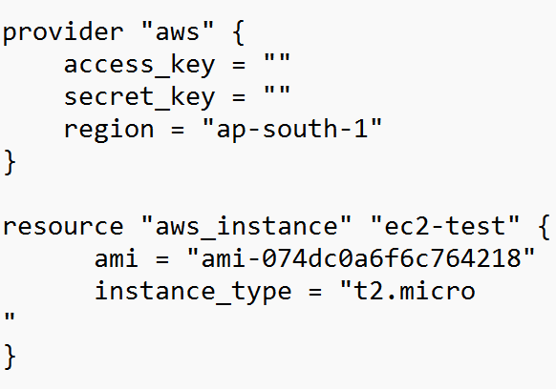

Run the commands:

terraform init, terraform plan and terraform apply.

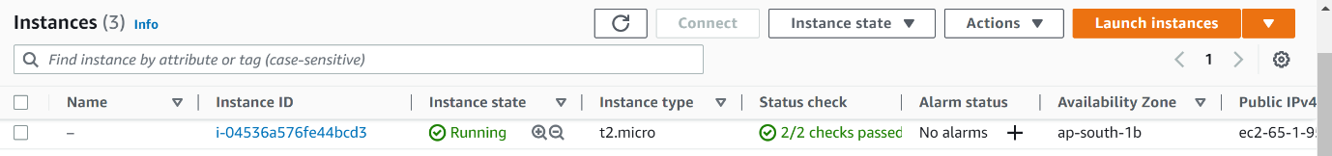

Change t2. micro  t2. small instance type in ec2.tf

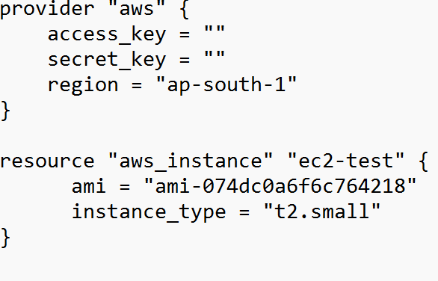

Then run terraform plan and terraform apply.

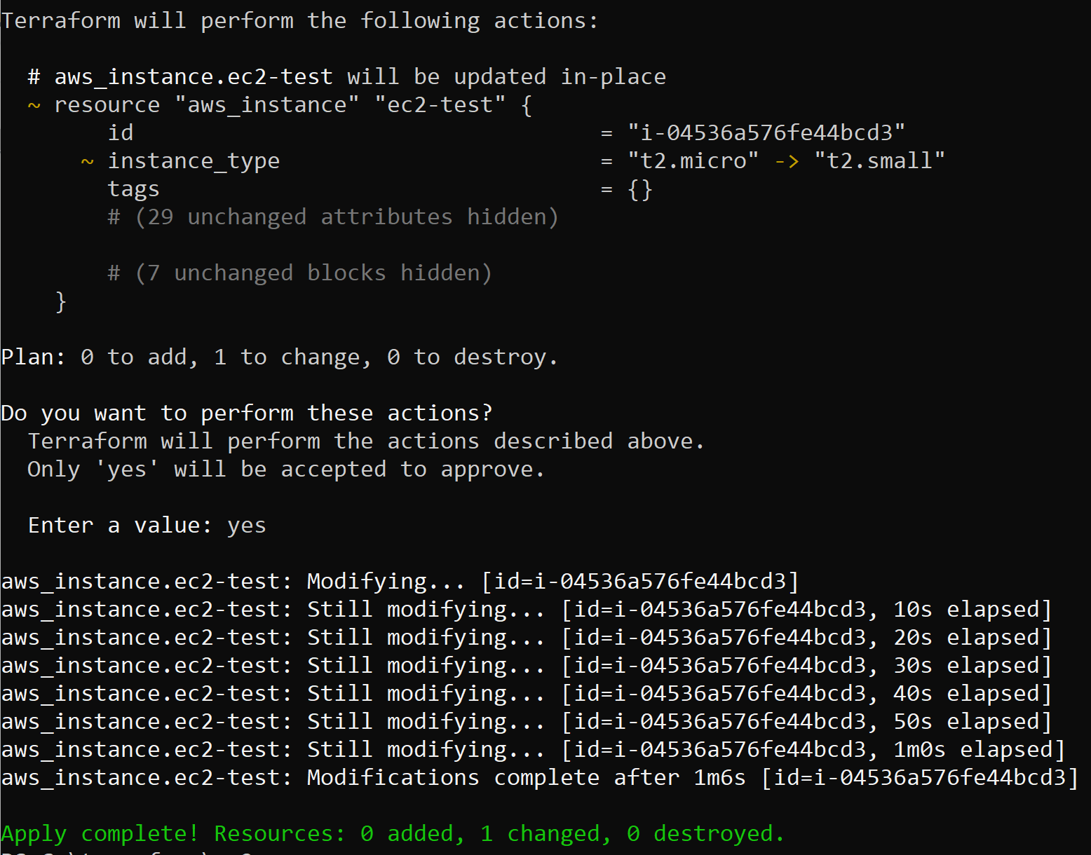

**Install Apache webserver on the EC2 instance using userdata script.**

This is my userdata script.

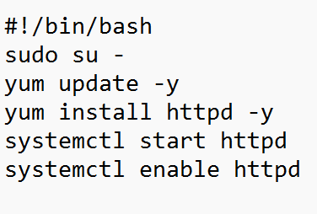

This is my ec2.tf file with userdata script file.

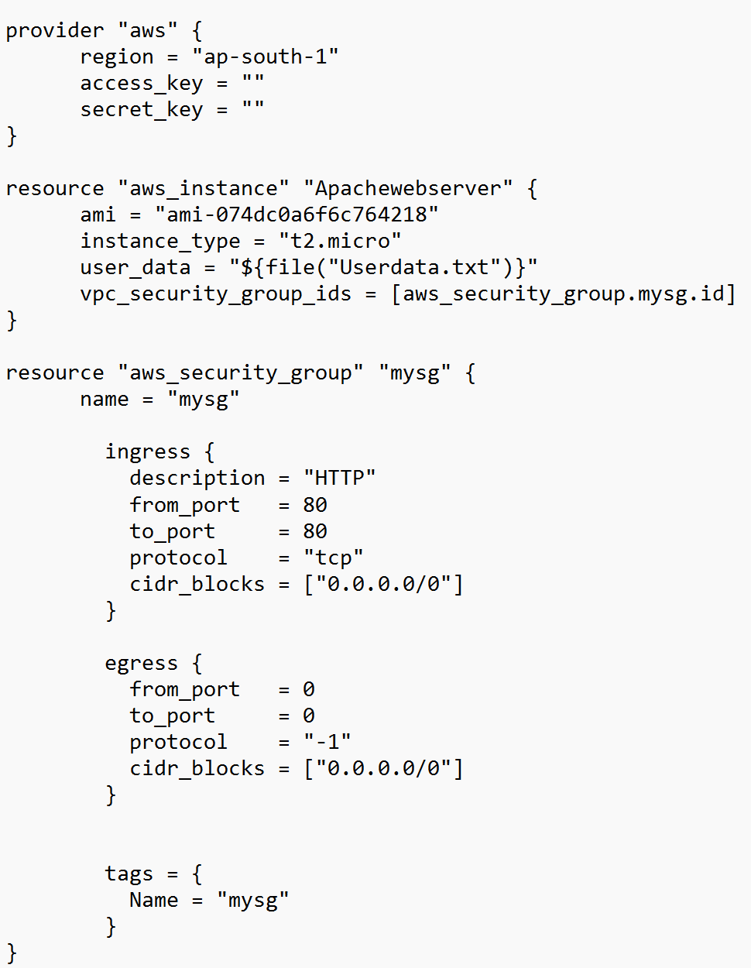

Run the commands:

terraform init, terraform plan and terraform apply.

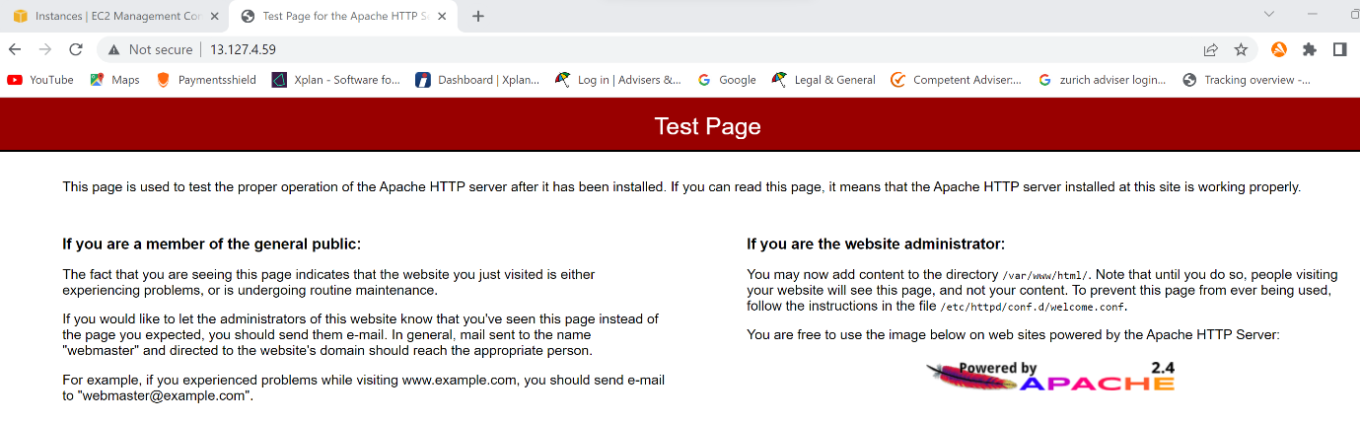

**Task 3 Create EBS Volume in a particular AZ of your choice, define size 10GB, encryption=false, tag=your name.**

This is ebs.tf file with demands.

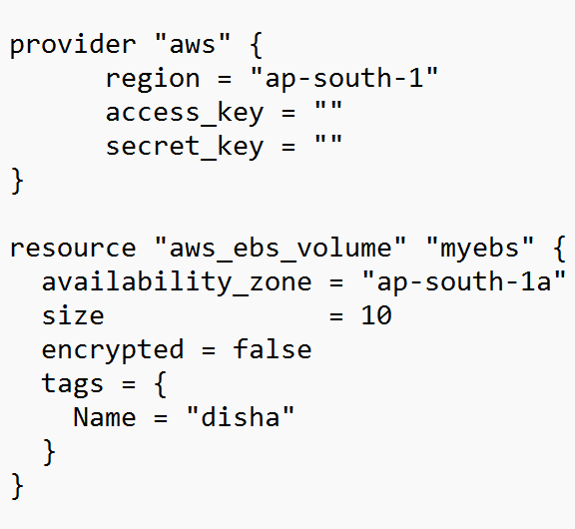

Run the commands:

terraform init, terraform plan and terraform apply.

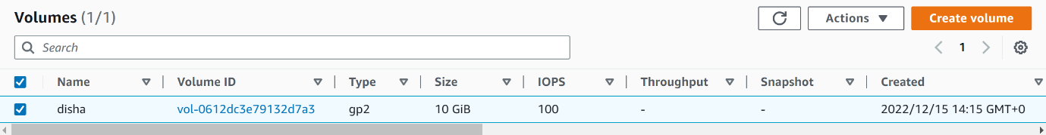

**Create Security Group – allow SSH port**

This is my sg.tf file.

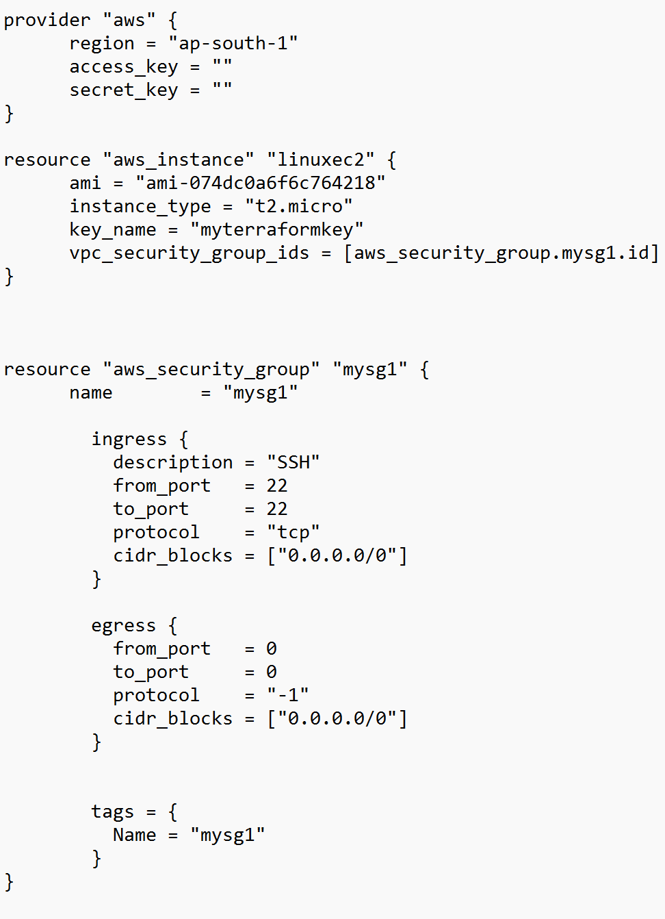

Run the commands:

terraform init, terraform plan and terraform apply.

